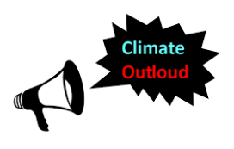
Climate Outloud Program
Downtown Renton Library, Main Conference Room
100 Mill Ave. So., Renton, WA 98056
Saturday, October 21st, 2017

10:00 AM Library Conference Room Opens for Set up
Non-Profit Organizations set up Tables with Info Materials
Volunteers Set-Up Chairs
11:00 AM Welcome, Acknowledgements, Introductions, & Overview of the Event
11:30 AM Climate Change - Power Point by Plant 4 the Planet and Plaintiffs

12:30 PM Jamie Margolin and Open Mic with Kids
1:00 PM Lunch Break; Visit Non-profit Tables
2:00 PM Introduction of the Panelists
Panel Discussion with Attorneys and Plaintiffs – Questions and Answers
3:30 PM Closing Comments – How to get involved in Climate Activism
3:45 PM Event Survey – Thank you to Participants!
4:00 PM Volunteers stack Chairs and Tables
5:00 PM Library Closes

