The Youth March for Climate Action Now
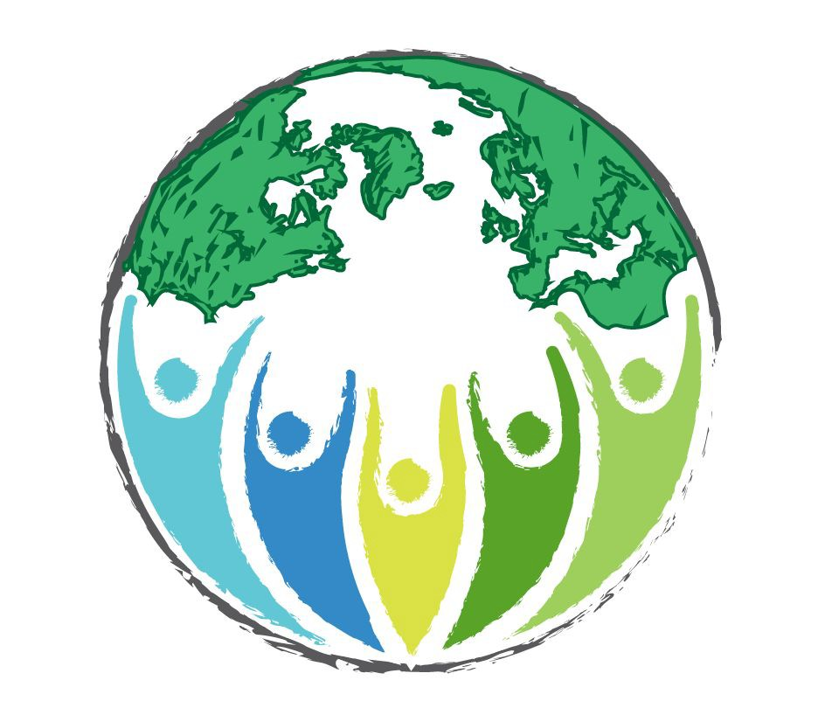
In Summer of 2018- Youth March for our rights to a livable future, free of climate chaos.

To learn more about the movement and how you can be a part of it, follow us!

Facebook: @TheYouthMarch Twitter: @TheYouthMarch Instagram: @The Youth March

(And share our social media with your communities!) Official march launch will be at the end of 2017

