The Shark Garden Annual Report 2016
Vision: We envision a garden park where everyone can come to learn, grow, and contribute to building food security, science education, and community.
Motto: Share what you know and share what you grow!
History:
The Shark Garden was founded in the spring of 2015 by the Community Advisory Board for New Start High School, a Highline District school for at risk teens, to support the summer gardening program, Youth Works, that summer. Several board members visited some 15 other area community gardens in the area and the Bradner Gardens, in Seattle, was chosen as our role model. While Seattle has nearly 100 community vegetable gardens, most with waiting lists, there is only one in the Burien area. A survey was created to determine what features the public was interested in. The survey was administrated to around 100 community members, including students, and a plan for the former play field was donated by a local landscape designer, based on the survey results. The plans dedicate about a third of the 1.6 acre site to a school garden, which came to be known as the Shark Garden after the High School mascot. The remaining two thirds would be divided between a community garden area and a pea patch style garden with plots for rent. The community garden area would ideally include: an office and meeting spaces, restrooms, storage, ADA accessible beds for seniors and wheelchairs, a children’s garden area, and many more features. A community orchard would form the northern border of the site and be the location for the gardens’ bee hives.
The high school summer gardening program started in the summer of 2015 and the nearly 30 high school students began construction on the garden, using almost entirely donated materials. The small budget available went to buying enriched garden soil for the new beds. The students built a shed, compost bins, beds, and paths and then planted them with donated fruit trees, vegetables, and flowers. By the season’s end we had produced enough vegetables to donate over 100 pounds of food to the White Center Food Bank. A Facebook page was created by a volunteer to document the amazing changes that were happening, recognize donors, and engage the students, neighbors, and others. With the help of tireless volunteers, donors, and summer program staff, the garden sprang to life.
2016 Achievements:
The Shark Garden grew by leaps and bounds in 2016, in both features and support. We installed 53 new raised beds, including 20 that are wheelchair accessible. That brings our total to 80 vegetable beds. A new 20 x 30 foot stage was built in the old batting cage to provide space for outdoor class time or concerts in the park. A 40 foot long cargo container was donated, delivered, and set up as additional storage space. A gravel road was added to connect the western entrance to a new southern arbor gate entrance. Four large bed areas were prepared as public pea patches and currently the District is exploring potential partnership opportunities with the Burien Parks Department for this community area. Another landmark was reached when a new water meter was funded and installed, by the community, so that the garden will now have its own water supply. The $8,000 price tag for the water meter was split between the Highline School District and individual donors. The new 400 square foot demonstration rain garden was completed and planted with native plants. The greenhouse was moved from the high school courtyard over to a spot next to the rain garden. A Shark Garden mural was created by students on the school portable wall, facing the garden. The fence along the western side of the garden was also given a fresh coat of paint. All of these improvements have really started to give the garden an identity in the community.

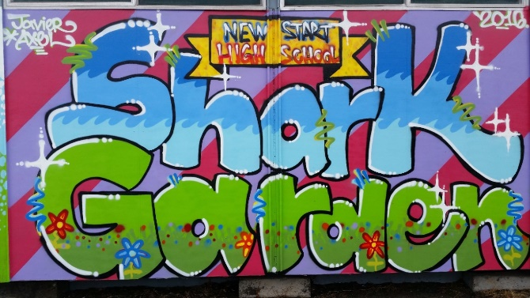
The new Shark Garden mural. This image will likely be the cover of our Thank You cards.
Donations of time, funds, and materials poured in to the Shark Garden project, in 2016. Volunteers served over 1,300 hours in the garden this year. This included labor by members of the Environmental Science Center, the Weed Warriors, members of NAIOP, and our own volunteer board members and their friends and families. Material donations valued at over $70,000 helped us build and fill all of the new beds, build the road and stage, deliver and place the new storage container, mulch the paths, paint the fence and shed, and make plans for new beds, benches, and compost bins next season. We want to give a special thanks to McLendon’s in White Center, Dunn Lumber in Normandy Park, True Value Hardware in West Seattle, the West Seattle Home Depot, Perennial Intrigue Vegetables, McKinstry Construction, Burien Press, Burien Bark, and Delta Air Lines for their corporate donations and support. We also received generous organizational support and donations from the Puget Sound Chapter of the Commercial Real Estate Development Association (NAIOP), the Environmental Science Center, Solid Ground’s Lettuce Link Program, the Burien Parks Department, the Union Gospel Mission, the Highline School District, and the Weed Warriors.
September 24th 2016 was a particularly special day, in the Shark Garden, when 457 volunteers from NAIOP came to volunteer on the New Start campus. About a third of them worked in the garden area, serving around 914 hours! The NAIOP brought with them an estimated $164,000 worth of materials and equipment donations to the campus and around $55,000 of that was spent in the Shark Garden. Other parts of the school campus received improvements that included landscaping, painting, new signage, new picnic tables, and various other repairs. We are very grateful for all of these improvements. Photos and videos can be seen on our Facebook page from that day.
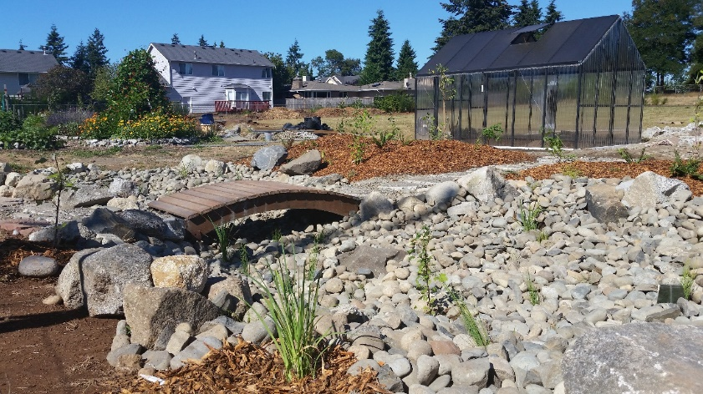
The new Rain Garden includes a foot bridge and a variety of native plants.

Individual donors supported the Shark Garden with donations of funds to help pay for the water meter, plants and seeds, a fig tree, landscape design time, photography and social media skills, garden tools, and the use of their vehicles to transport other donations. A special thanks goes out to Dr. Gene & Carol Sharratt and John and Nancy Feeney for funding our new water supply. Our resourceful board members scoured craigslist for free items that we could use in the garden and we now have a fountain, rain barrels, raised bed construction materials, and a variety of other garden supplies, tools, and building materials. This community support from both individuals and organizations is critical to the sustainability of the garden.
The Shark Garden is gaining support and new partnerships as the word gets out about our success. We more than tripled the amount of produce that was donated to the community since that year. We were able to contribute 370 pounds of produce to students, neighbors, volunteers, the soup kitchen at Transform Burien, and the White Center Food Bank, up from 100 pounds last year. Fifty three students and young people used the garden through the summer school program, the key club, and after school programs. We hope to engage even more youth in the next year as the garden becomes a destination for field trips for area schools. The teachers at Hazel Valley Elementary School are interested in adding a garden visit to their work with special needs students. Programs in urban horticulture at Highline Community College and South Seattle Community College are interested in getting involved with the garden, as well. Several boy scouts have inquired about doing their Eagle Scout projects in the garden. We hope to see the garden used as a host location for a variety of school programs, garden clubs, community groups, and events.

Our Shark Garden supporters and board members are working hard to create a long term plan for the garden and we have set some goals for the 2017 season. Our primary project will be the irrigation system and the acquisition of additional garden soil, fruit trees, and construction materials. Projects include additional beds, new compost bins, bench seats, a children’s garden area, a concrete-floored materials drop off area, a bee enclosure, shark themed garden artwork, new educational signage, a blueberry patch, and the development of a website.
We will seek donations of plants, soil, tools, ecology blocks, plumbing and irrigation parts, equipment rentals, concrete, and construction materials, in 2017. A solar panel to run the irrigation timer would also be great. We have purchased the domain name for our website, but capacity building funds will be needed to pay for its creation and the other administrative costs like printing thank you cards, social media marketing, and accounting. We are improving our ability to attract, manage, and track volunteers and donations with each season. The future of the Shark Garden is bright and, as our motto suggests, we will share what we know and share what we grow as it develops into a vital part of the Burien community.
Our Facebook page can be found here: https://www.facebook.com/theSharkGarden/

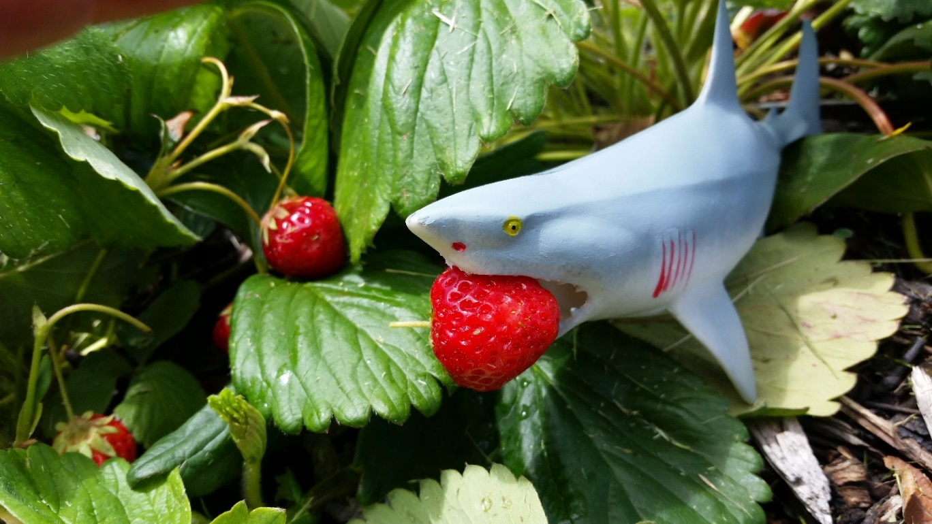
Example of one of our most popular Facebook posts, our mascot showing what was fresh that day.

Our Facebook feed focuses on science, organic gardening, school gardens, local events put on by our supporters, healthy recipes you can use with produce from the garden, volunteering, green technology, food security, and DIY projects for your garden. We try to include as many original photos as possible. We have a couple of toy sharks that act as our photo models.
We actively monitor many local social media outlets for opportunities to connect with likeminded individuals and organizations. We are members of the local Nextdoor online community and the West Seattle Urban Farmers Facebook group. We follow and support another 20+ local organizations online. Our goal is to raise awareness for the Shark Garden. The creation of our website will help to solidify our identity and give interested parties a place to visit and learn about our garden. Efforts are currently underway for the creation of logos and other marketing materials. All of this, including the Facebook and Pinterest pages, is managed by volunteers.
Our Pinterest page can be found here: https://www.pinterest.com/oursharkgarden/
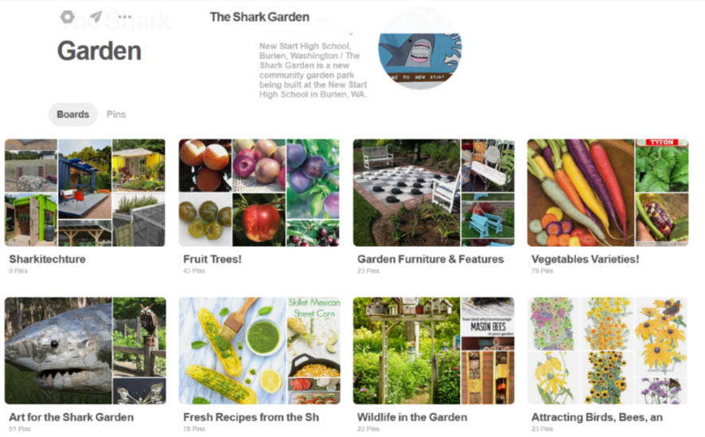
Our Pinterest page emphasizes organic gardening, science education, healthy eating (vegetable recipes), garden DIY and projects, and information about various edible plants. The pins have been screen to be family friendly.

Contact Us:
If anyone is interested in learning more about the Shark Garden, please let us know.
For materials donations, volunteering or a tour: John Feeney, Board Member: CLEELLUM2003@msn.com
For financial donations or partnerships: Michael Sita, Principal of New Start H. S.: michael.sita@highlineschools.org
You can also message us via Facebook.

